Dynamic Pathfinding Agent – Comprehensive Report

1. Project Objective
The objective of this project is to develop a Dynamic Pathfinding Agent capable of navigating a grid-based environment using informed search algorithms such as A* Search and Greedy Best First Search (GBFS).
The system is designed to operate in both static and dynamic environments. In dynamic mode, obstacles may appear randomly while the agent is in motion, requiring the agent to detect the obstruction and perform real-time path re-planning to reach the fixed goal node efficiently.
2. Implementation Logic
A* Search Implementation
A* Search is implemented using the evaluation function:
F(n)=g(n)+h(n)
Where:
- g(n) = Cost from the start node to the current node
- h(n) = Heuristic estimate from the current node to the goal
- f(n) = Total estimated cost
A priority queue (min-heap) is used to always expand the node with the smallest $f(n)$.
Each node maintains:
- g-value
- h-value
- f-value
- Parent pointer
The parent pointer is used to reconstruct the final path once the goal node is reached.
A* guarantees an optimal solution when the heuristic used is admissible.
Greedy Best First Search (GBFS) Implementation
Greedy Best First Search uses only the heuristic value:
$$f(n)=h(n)$$
Unlike A*, it ignores the path cost $g(n)$and expands the node that appears closest to the goal according to the heuristic.
This makes GBFS faster in certain cases but it does not guarantee an optimal path because it may follow misleading heuristic directions.
Heuristic Functions
Two heuristic functions were implemented:
1. Manhattan Distance
$$D_{manhattan}=∣x_{1}-x_{2}∣+∣y_{1}-y_{2}∣$$
- Suitable for 4-directional grid movement (up, down, left, right)
- Admissible and consistent for grid-based maps
2. Euclidean Distance
$$D_{euclidean}=\sqrt{\left(x_{1}-x_{2})^{2}+(y_{1}-y_{2})^{2}\right.}$$
- Calculates straight-line distance
- More realistic for diagonal distance estimation
- Also admissible
3. Dynamic Obstacle Handling and Re-Planning
When Dynamic Mode is enabled:
- At each time step, there is a small probability that a new obstacle appears.
- The system checks whether the newly spawned obstacle blocks the agent’s remaining path.
- If the current path is blocked, the algorithm immediately re-runs the selected search strategy from the agent’s current position.
- If the obstacle does not affect the current path, the agent continues without recalculating.
This ensures computational efficiency and avoids unnecessary full resets of the search process.
4. Pros and Cons Based on Experimental Findings
A* Search
Advantages:
- Guarantees optimal path (with admissible heuristic)
- Balanced exploration between cost and direction
- Performs reliably in complex maps
- Handles dynamic re-planning efficiently
Disadvantages:
- Slightly slower than Greedy in simple environments
- Requires more memory (stores g-values and parents)
4.2 Greedy Best First Search
Advantages:
- Faster in open environments
- Less computation in simple cases
- Lower memory overhead
Disadvantages:
- Does not guarantee optimal path
- Can explore wrong directions in complex maps
- Performance degrades significantly in maze-like environments
5. Test Cases (Visual Proof Required)
For experimental validation, screenshots must be provided for each algorithm under two scenarios:
A* Search
- Best Case Scenario (minimal node expansion, direct path)
- Worst Case Scenario (large expansion before reaching goal)
Greedy Best First Search
- Best Case Scenario (direct goal guidance)
- Worst Case Scenario (misleading heuristic leading to large exploration)

Screenshots:
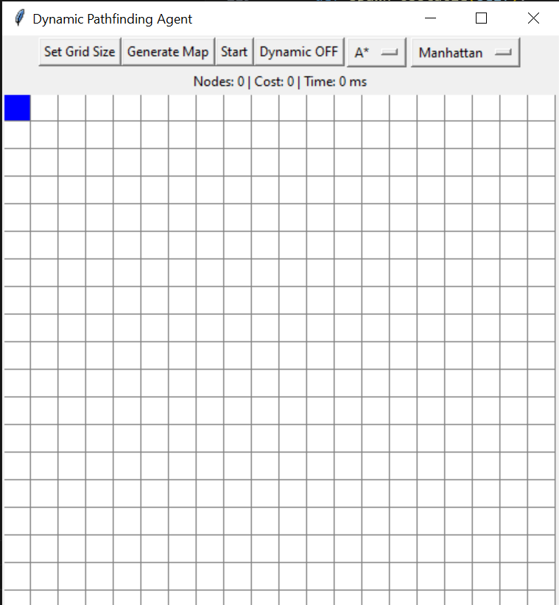


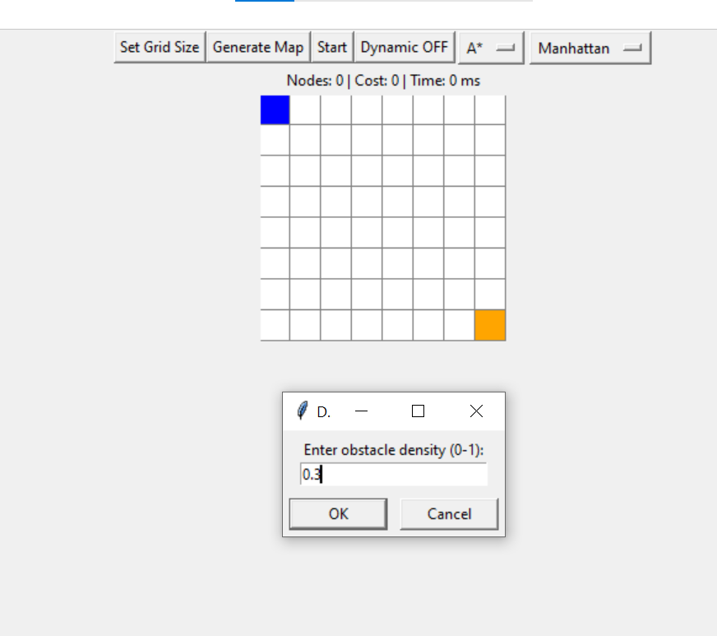
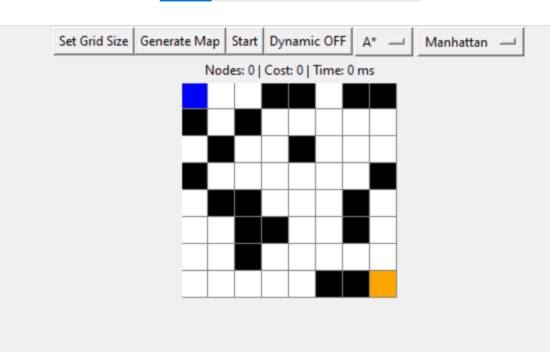
Worst case:

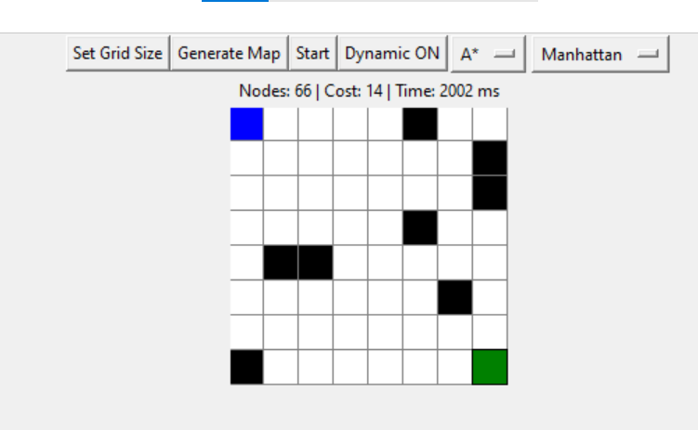
Best case:
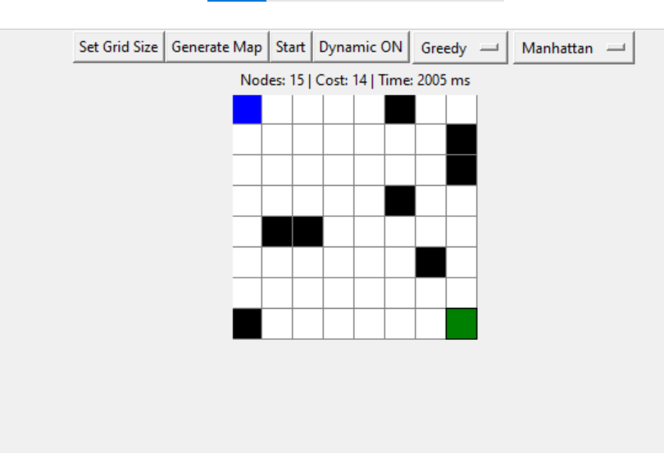
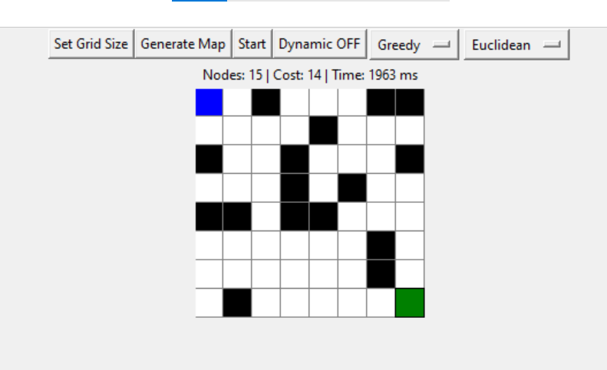
Path not found:
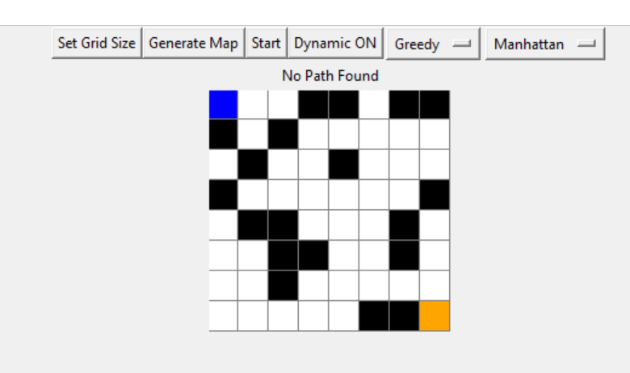

- Frontier nodes (highlighted in Yellow)
- Visited/Expanded nodes (highlighted in Red/Blue)
- Final optimal path (highlighted in Green)
- Metrics Dashboard including:
  - Total Nodes Visited
  - Final Path Cost
  - Execution Time (milliseconds)
6. Conclusion
The experimental results demonstrate that A* Search provides more reliable and optimal solutions, especially in complex and dynamic environments. Greedy Best First Search performs faster in simple maps but may fail to find optimal paths in complicated grid structures.
Dynamic obstacle handling significantly increases realism and demonstrates the practical importance of re-planning mechanisms in real-world navigation systems such as robotics, autonomous vehicles, and game AI.

